PHASE 3 WALKTHROUGH

PROJECT OVERVIEW
The Ride Sharing Event Pipeline is an event-driven application developed using Apache Kafka and Python. The objective of the project is to simulate ride-sharing events, process completed rides, calculate driver earnings, and generate driver performance reports. The system uses multiple Kafka topics and consumers to process ride events in real time.

KAFKA TOPIC CREATION
Before executing the Ride Sharing Event Pipeline, the required Kafka topics were created using Kafka CLI commands.
The following topics were created:
• RIDE.EVENTS – Stores all ride events generated by the producer.
• RIDE.COMPLETED – Stores only completed ride events after filtering.
• DRIVER.EARNINGS – Stores processed driver earnings information.
Each topic was created with 3 partitions and a replication factor of 1. These topics act as communication channels between producers and consumers and form the foundation of the event-driven pipeline.
The separation of topics improves scalability, maintainability, and enables independent processing of ride events and analytics data.

PUBLISHING RIDE EVENTS TO RIDE.EVENTS
The dataset used for the project is stored in the file rides.csv.
Each ride record contains the following information:
• Ride ID
• Driver ID
• Rider ID
• Ride Status
• Latitude
• Longitude
• Timestamp
The rider_producer.py application reads ride records from the CSV file and publishes them to the Kafka topic RIDE.EVENTS.
This simulates real-time ride events generated by a ride-sharing platform. Every record in the dataset becomes an event in Kafka and is made available for downstream processing.
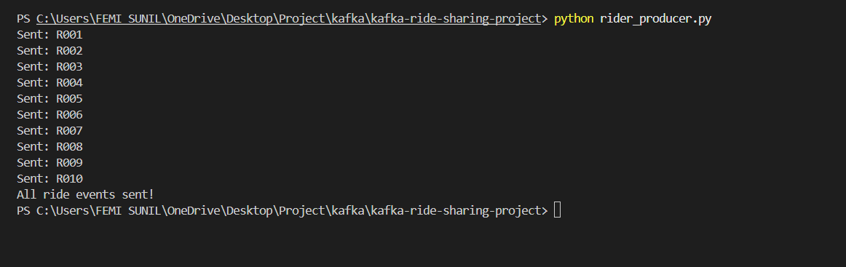

FILTERING COMPLETED RIDES
The completed_rides_consumer.py application subscribes to the RIDE.EVENTS topic.
For every incoming ride event, the consumer checks the ride status. If the status is COMPLETED, the event is forwarded to the RIDE.COMPLETED topic. All other events are ignored.
This filtering process ensures that only relevant ride events are used for earnings calculation and reporting.
The implementation demonstrates event filtering, which is a common pattern in event-driven architectures.
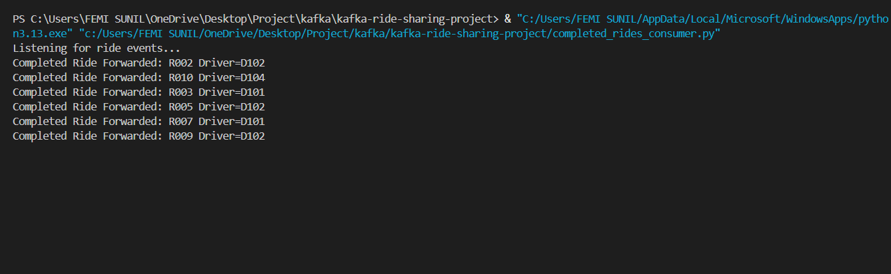

DRIVER EARNINGS CALCULATION
The driver_earnings_consumer.py application consumes messages from the RIDE.COMPLETED topic.
For every completed ride:
• The completed ride count is incremented.
• Driver earnings are updated.
For simplicity, a fixed earning rate of $5 per completed ride is used.
Formula:
DRIVER EARNINGS = COMPLETED RIDES × $5
The consumer continuously updates driver statistics as new completed rides arrive.
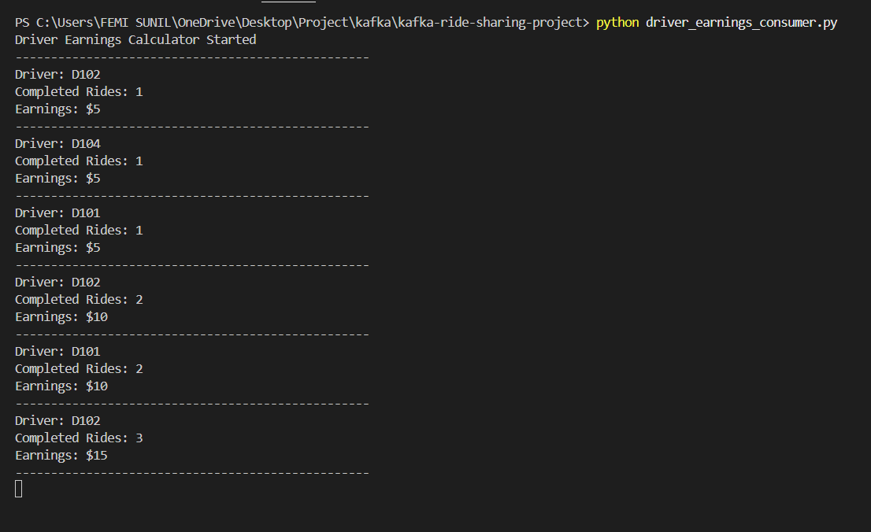

TOP DRIVERS REPORT
The top_drivers.py application generates a report of the top-performing drivers based on completed rides.
The report ranks drivers according to the number of completed rides processed by the system and displays the results in descending order.
This provides a simple analytics dashboard through the command-line interface and demonstrates how business insights can be derived from streamed events.

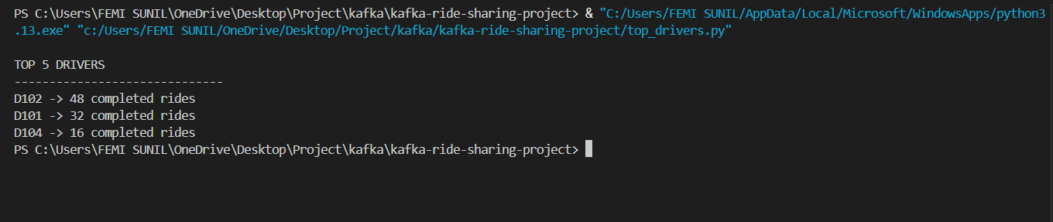

ARCHITECTURE OVERVIEW
The overall data flow of the Ride Sharing Event Pipeline is shown below:
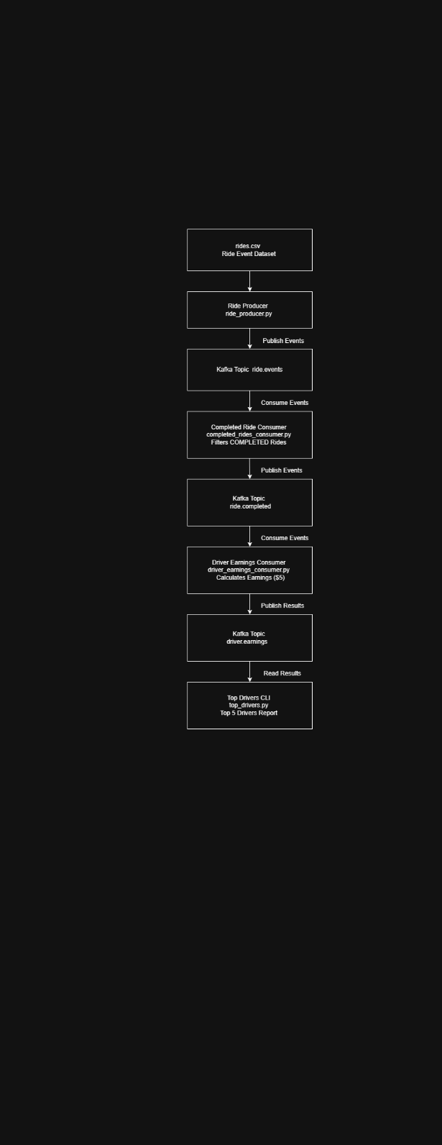

CONCLUSION
The Ride Sharing Event Pipeline successfully demonstrates the implementation of a Kafka-based event-driven application. Ride events are streamed through multiple Kafka topics, filtered according to business rules, processed to calculate driver earnings, and finally used to generate driver performance reports.
The project provided practical experience with Kafka Producers, Kafka Consumers, Kafka Topics, Event Filtering, Stream Processing, Real-Time Analytics, and Event-Driven Architecture. The modular design of the system allows it to be extended further for large-scale ride-sharing applications and real-time analytics platforms.

